

Community Food Support
Grant Application Guidance
- About the Food Poverty Fund

As part of the work to alleviate the impact of poverty for residents North Tyneside cabinet have committed to 6 pillars of support. One of these pillars being food insecurity, cabinet has identified funding from the Poverty Intervention Fund to help with the cost and access to affordable food.

North Tyneside Council has allocated £64,000 from the Poverty Intervention Fund for food support. These funds are offered and administered by North Tyneside Council as food poverty funding. Funds are distributed, via an application process, to assist those in our communities who are vulnerable and struggling with food poverty and insecurity. Applications are considered by a Fund Assessment Panel. The panel’s decision on applications is final and there is no appeal process.

- What are the grant funding criteria?
To support people facing food poverty in the priority areas by:
  - Strengthening / developing community food initiatives / schemes
  - Supporting activities that focus on addressing the root causes of food poverty.
  - Helping to develop activities by local community groups, voluntary organisations, and housing associations etc to start up projects like social supermarkets, community cafes, lunch clubs and cookery classes.
  - To develop and/or strengthen food partnerships with a view to creating sustainable local food schemes that could tackle food insecurity.
  - To provide support for outreach work and volunteer training (around community food provision).
  - To develop hubs, built around community food provision, to share a range of support services – debt, housing advice, holiday hunger schemes etc.
  - To support community food organisations that are experiencing difficulties in operating effectively. This may relate to, for example but not limited to, expenses such as overhead costs, volunteer expenses or support to meet additional costs incurred because of increased costs.
  - To provide organisations with some capital funding to spend on items such as, but not limited to, fridges, freezers, and cooking equipment.
  - The Local Authority will work collaboratively with a number of organisations across the sectors in order to maximise the impact of this funding for a sustainable, long-term approach to community food resilience.

- Priority areas
  - The community Food Support Grant has identified areas of priority based on the below map:
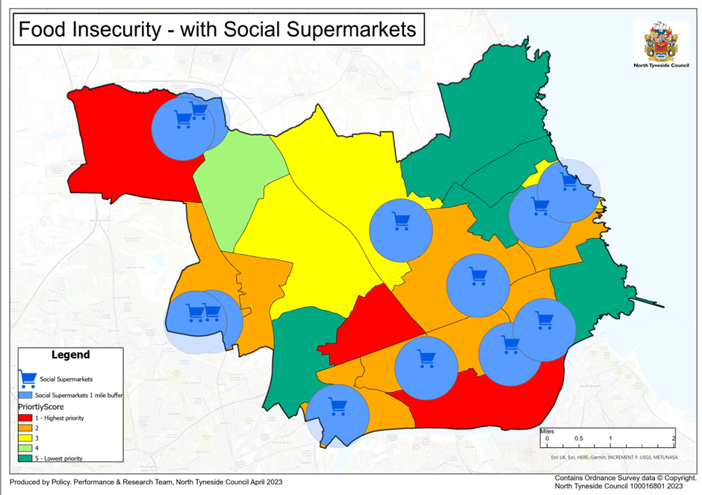
  - The fund will prioritise:
    - New food support projects in areas of high food insecurity, with a lack of existing social supermarkets.
    - Existing food support projects in areas of high food insecurity.

- Who is eligible or not eligible to apply for funding?
  - Eligible:
    - All voluntary / community organisations that are constituted with a bank account in the name of that organisation (requiring at least two authorised signatures to access funds).
    - Local charities and not for profit organisations can apply.
    - Schools will be eligible to apply for activities supporting the prevention or alleviation of food poverty.
  - Not eligible:
    - The fund will not support statutory activity that should be financed by statutory agencies. Non-statutory activity, based on the prevention or alleviation of food poverty, however, is eligible for funding.
    - Grants will not be awarded to private individuals.
  - Before you apply you must have:
    - A project plan outlining how your project will be sustainable following the initial funding investment.
    - The capability to deliver community food provision.
    - Access to fresh food that will enable the community to cook nutritious meals.
    - Experience in providing fresh food in a community setting which is accessed by the local community.
    - Knowledge of the community that you will be delivering your provision in and how you plan to meet their needs.

- How much funding is available?

  - The community food provision grant is to support VCSE and/or CICs to support residents in areas that have been prioritised as areas of food insecurity. There are grants available for applications for up to £10,000, the total value of funding is £64,000.

- What can and cannot be funded:
  - Examples of eligible spend includes but are not limited to:
    - Purchasing additional supplies of food and essential goods
    - Fareshare membership fees;
    - Community growing/cooking projects where the aim is to tackle food poverty;
    - Additional costs incurred as a result of increased demand;
    - Costs incurred as a result of additional outreach work required, especially to reach the most vulnerable;
    - Training for volunteers;
    - Support for organisations that are experiencing difficulties in operating effectively. This may relate to, for example but not limited to, some overhead costs, volunteer expenses or support to meet additional costs incurred as a result of increased demand such as those relating to additional deliveries.
    - Start-up costs for developing services around community food provision, such as:
      - Social supermarkets;
      - Community cafes;
      - Lunch clubs;
    - Advice services and hubs built around community food provision and/or signposting to agencies that can help with issues leading to food poverty;
    - food partnerships, with a view to creating local food schemes that help tackle food insecurity.
  - Ineligible spend:
    - This grant is unable to cover an organisation’s annual running costs and costs associated with its normal everyday business aims and objectives. E.g., staff costs, utility bills, insurance costs etc.

- Application process
  - Information regarding the fund will be announced via NTC’s social media channels and advertised on NTC’s website. Applicants can apply from September 2023.
  - Information regarding the fund will be announced via NTC’s social media channels and advertised on NTC’s website. Applicants can apply from September 2023
  - Application forms can be downloaded from the NTC website or are available by emailing food@northtyneside.gov.uk
  - Organisations can apply more than once as long as submissions are for different or relate to an earlier application, but the activities are complementary activities not included in the earlier application.
  - Potential applicants are encouraged to discuss applications, prior to submission, with a Social Inclusion officer via food@northtyneside.gov.uk
  - Supporting documentation that has been requested needs to be provided. Incomplete applications will not be considered.
  - The applicant must declare that, to the best of their knowledge and belief, the information contained in the application is correct and the person signing off the application is authorised to do so.
  - Applications will be evaluated by an assessment panel. The panel’s decision is final and there is no appeal process.
  - The applicant will receive the outcome of the assessment in writing via an email to the contact supplied on the application form.
  - If successful, the applicant will be required to sign and agree Terms and Conditions which constitute an offer of funding, prior to initiating any expenditure.
  - If the information offered in the application changes, the applicant must inform the Fund immediately.
  - If funding is awarded, it is to be used only for the purposes approved in the offer letter. The Fund reserves the right to recover grant aid that is used for any purpose other than the approved purposes.
  - The applicant will abide by the Terms and Conditions of the Fund. Any deviations to this agreement must be agreed with the Social Inclusion Manager
  - All successful applicants will be required to complete a Funding Completion Report. This must be completed as soon as the grant has been spent. A blank Funding Completion Report will accompany the letter of acceptance.
  - Successful applicants will be required to provide evidence of their expenditure, all monies not spent or accounted for will have to be returned to the Fund.
  - Each application will be assessed on its merits and fit with the funding criteria or an identified food poverty need.
  - All successful applicants must have registered with environmental health in advance of grant payments being made.
  - Successful applicants will need to spend their allocated funding by 31 March 2024.

