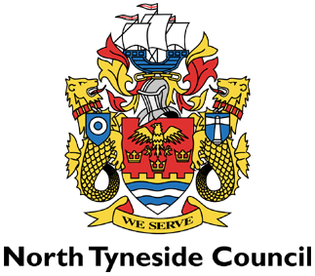

Appeal Form

Notes for businesses
• As the food business operator of the establishment you have a right to appeal the food hygiene rating given following your inspection if you do not agree that the rating reflects the hygiene standards and management controls found at the time of the inspection.
• You have 21 days (including weekends and bank holidays) from the date of receipt of the notification letter to lodge an appeal.
• Please use the form below and return it to the Lead Officer for Food at North Tyneside Council - contact details are provided with the written notification of your food hygiene rating.
• The Lead Officer for Food will review your rating and communicate the outcome of your appeal to you within 21 days.

Food business operator/proprietor
Business name
Business address

Business tel. no.
Business e-mail

Date notified of rating

Date of inspection
Food hygiene rating given

I do not agree with the food hygiene rating given by the food safety officer because (please explain below under each of the three headings):

Compliance with food
hygiene and safety
procedures
Confidence in
management/control
procedures

Compliance with structural
requirements

Signed
Position

Date

Name in capitals

