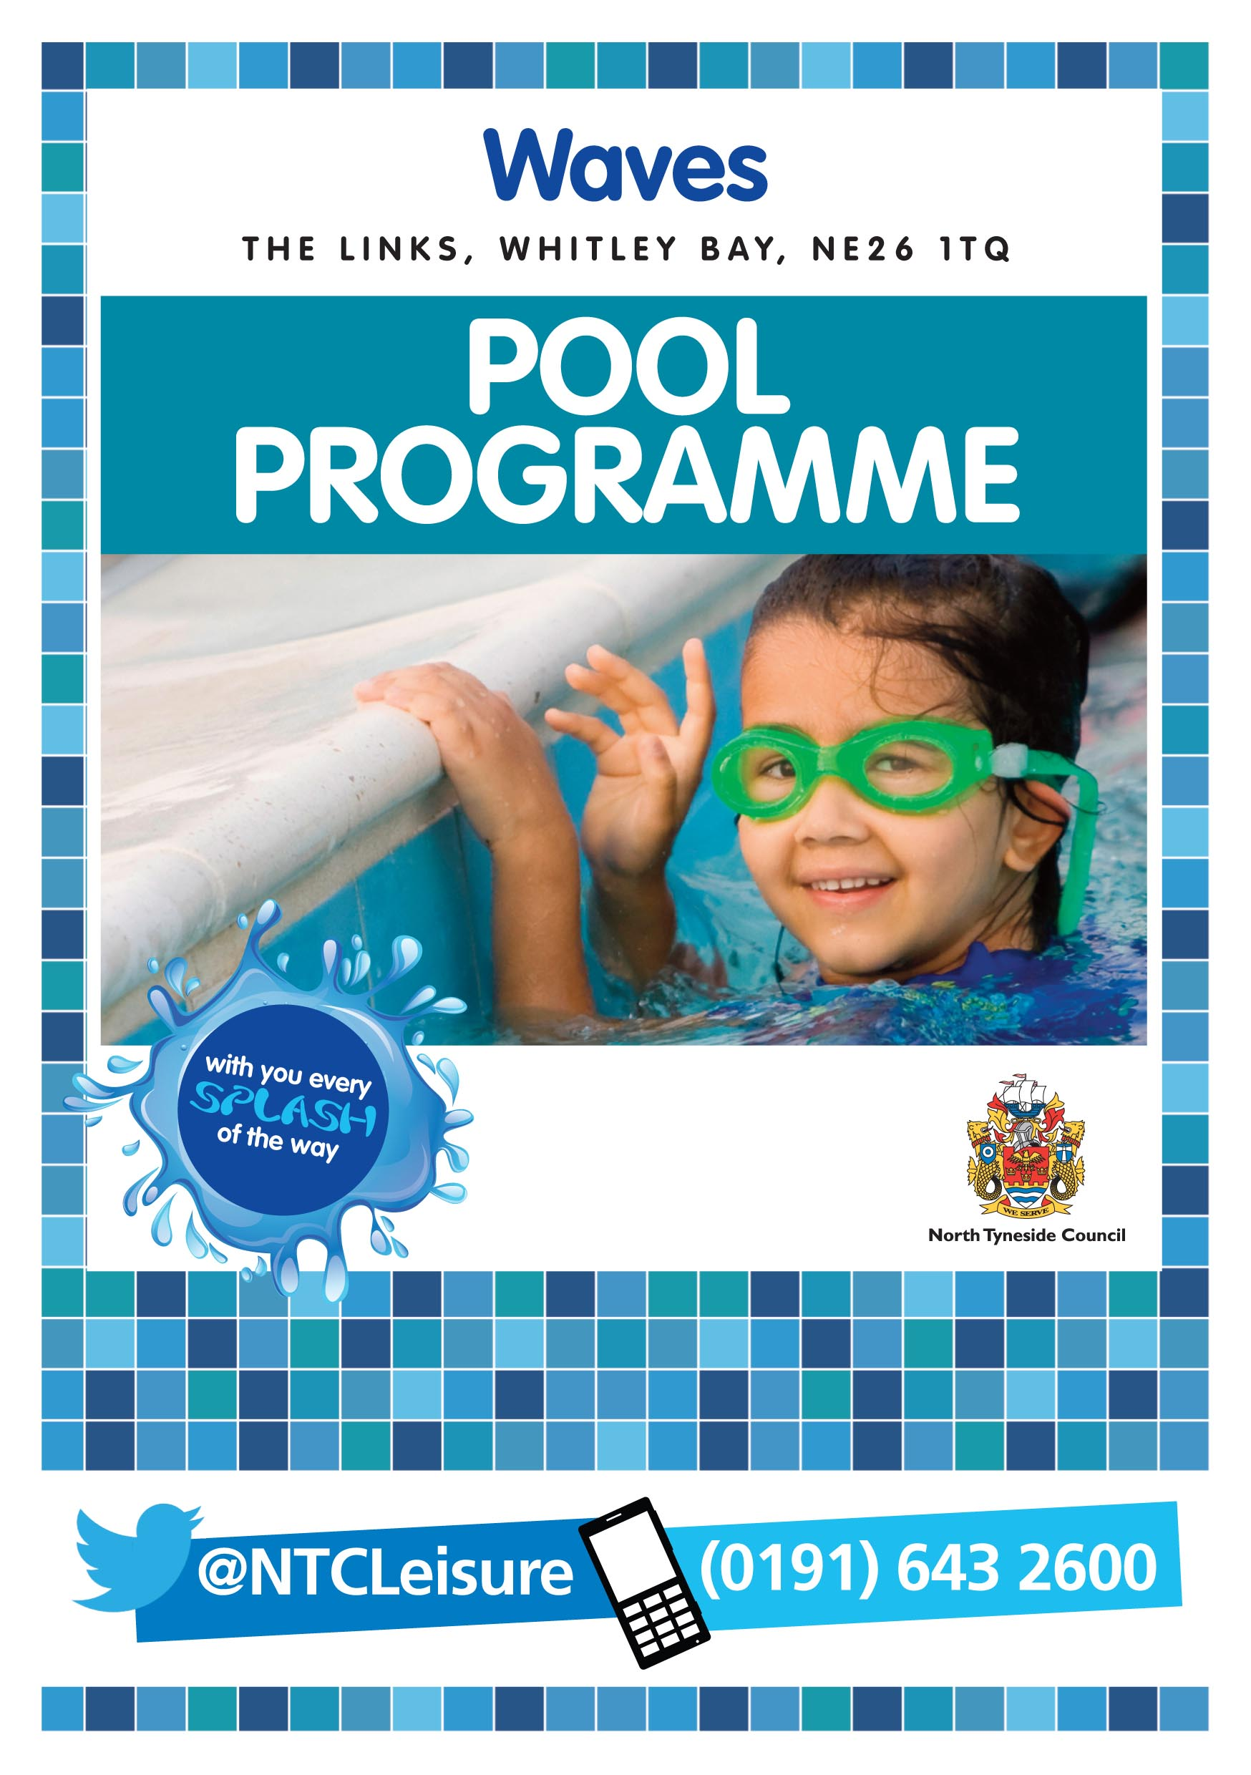

Summer 2025

21st July – 31st August inclusive



**Public swimming:**

|  |
| --- |
| **Main pool** |
| 6.30am–9.30pm (adults only from 8pm) |
| **Lane swimming** |
| 6.30am–9am |
| 6pm–9.30pm |
| **Small pool** |
| 10am–7.30pm |
| **Slide and Waves (intermittent)** |
| 10am–7.30pm |
| **Aquatic play** |
| 9am–7.30pm |

**Activities:**

|  |  |
| --- | --- |
| **Main pool** | |
| 9.10am–9.50am | Aquafit* |
| 8pm-8.45pm | Aquafit* |
| **Small pool** | |
| 8am-10am (week 1, 2 & 4) | Swimming lessons* |
| 2.40pm – 4.30pm (week one only) | Swimming lessons* |

*Section of main pool closed for activity / small pool closed for activity

PLEASE NOTE – You DO NOT need to book to swim at Waves, just come along!

**Bank Holiday Monday – 25th August 2025**

|  |
| --- |
| **Main pool** |
| 8am–4pm |
| **Lane swimming** |
| 8am–10am |
| **Small pool** |
| 9am–4pm |
| **Waves and slide** |
| 10am–4pm |
| **Aquatic play** |
| 8am–4pm |



**Public swimming:**

|  |
| --- |
| **Main pool** |
| 6.30am–9.30pm (adult only from 8pm) |
| **Lane swimming** |
| 6.30am– 7.50am |
| 6pm – 9.30pm |
| **Small pool** |
| 10am–7.30pm |
| **Waves and slide** |
| 10am–7.30pm |
| **Aquatic play** |
| 9am–7.30pm |

**Activities:**

|  |  |
| --- | --- |
| **Main pool** | |
| 8am–8.45am | Aquafit* |
| 7.30pm-8.30pm | Staff Training* |
| **Small pool** | |
| 8am-10am (week 1, 2 & 4) | Swimming lessons* |
| 2.40pm – 4.30pm (week one only) | Swimming lessons* |

* section of main pool closed for activity

PLEASE NOTE – You DO NOT need to book to swim at Waves, just come along!



**Public swimming:**

|  |
| --- |
| **Main pool** |
| 6.30am–6.20pm |
| 7.20pm-9.30pm (adults only) |
| **Lane swimming** |
| 6.30am–9.15am |
| 8.25pm–9.30pm |
| **Small pool** |
| 10am–7.30pm |
| **Waves and slide** |
| 10am–6.15pm |
| **Aquatic play** |
| 9am–6.15pm |

**Activities:**

|  |  |
| --- | --- |
| **Main pool** | |
| 9.25am–10.10am | Aquafit* |
| 2.30pm-3.30pm | Staff Training* |
| 5.15pm-6.15pm | Toys and Floats |
| 6.20pm–7.20pm | Additional Needs Session |
| 7.30pm-8.15pm | Aquafit* |
| **Small pool** | |
| 8am-10am (week 1, 2 & 4) | Swimming lessons* |
| 2.40pm – 4.30pm (week one only) | Swimming lessons* |

* section of main pool closed for activity

PLEASE NOTE – You DO NOT need to book to swim at Waves, just come along!



**Public swimming:**

|  |
| --- |
| **Main pool** |
| 6.30am–9.30pm |
| **Lane swimming** |
| 6.30am–8am |
| 6pm–9.30pm |
| **Small pool** |
| 10am–7.30pm |
| **Waves and slide** |
| 10am–7.30pm |
| **Aquatic play** |
| 9am–7.30pm |

**Activities:**

|  |  |
| --- | --- |
| **Main pool** | |
| 8.15am–9am | Aquafit* |
| 8.30pm-9.30pm | Swim to Trim |
| **Small pool** | |
| 8am-10am (week 1, 2 & 4) | Swimming lessons* |
| 2.40pm – 4.30pm (week one only) | Swimming lessons* |

* section of main pool closed for activity

PLEASE NOTE – You DO NOT need to book to swim at Waves, just come along!



**Public swimming:**

|  |
| --- |
| **Main pool** |
| 6.30am–7.30pm |
| **Lane swimming** |
| 6.30am–10am |
| **Small pool** |
| 9am-7.30pm |
| **Waves and slide** |
| 10am–7.30pm |
| **Aquatic play** |
| 9am–7.30pm |

**Activities:**

|  |  |
| --- | --- |
| **Main pool** | |
| 6.30pm–7.30pm | Wild Waves with Toys and Floats |

* section of main pool closed for activity

PLEASE NOTE – You DO NOT need to book to swim at Waves, just come along!



**Public swimming:**

|  |
| --- |
| **Main pool** |
| 8am–6pm |
| **Lane swimming** |
| 8am–10am |
| **Small pool**\*\* |
| 8am-6pm |
| **Waves and slide** |
| 10am–6pm |
| **Aquatic play** |
| 8am–6pm |

**Activities:**

|  |  |
| --- | --- |
| **Main pool** | |
| 5pm–6pm | Toys and floats |

|  |  |
| --- | --- |
| **Parties\*\*** | |
| 12pm–5pm | Small pool |
| 6pm-6.45pm | Main pool |

**Please check ahead with reception for any small pool party bookings which may limit use of this area

PLEASE NOTE – You DO NOT need to book to swim at Waves, just come along!



**Public swimming:**

|  |
| --- |
| **Main pool** |
| 8am–5pm |
| **Lane swimming** |
| 8am–10am |
| **Small pool**\*\* |
| 8am–5pm |
| **Waves and slide** |
| 10am–5pm |
| **Aquatic play** |
| 8.30am–5pm |

**Activities:**

|  |  |
| --- | --- |
| **Main pool** | |
| 5pm–6.30pm | Additional Needs Session |
| **Small pool** | |
| 8am–5pm | Toys and floats |

|  |  |
| --- | --- |
| **Parties\*\*** | |
| 12pm–4pm | Small pool |

**Please check ahead with reception for any small pool party bookings which may limit use of this area

PLEASE NOTE – You DO NOT need to book to swim at Waves, just come along!